**Creating a EC2 Linux WebServer**

**To launch an EC2 instance**

1. Sign in to the AWS Management Console and open the Amazon EC2 console at using your Administrator account. Make sure you’re in the **N. Virginia** region.
2. Choose **EC2 Dashboard**, and then choose **Launch instance**, as shown following.


                                EC2 Dashboard
                            

1. Name the Instance ***yourlastname*-WebSvr1**.   
   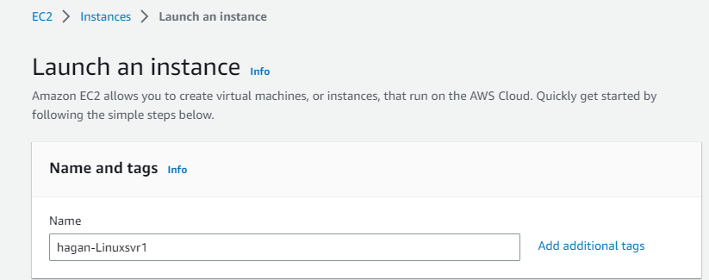
2. Choose the **Amazon Linux 2 AMI**. It should be the first one.

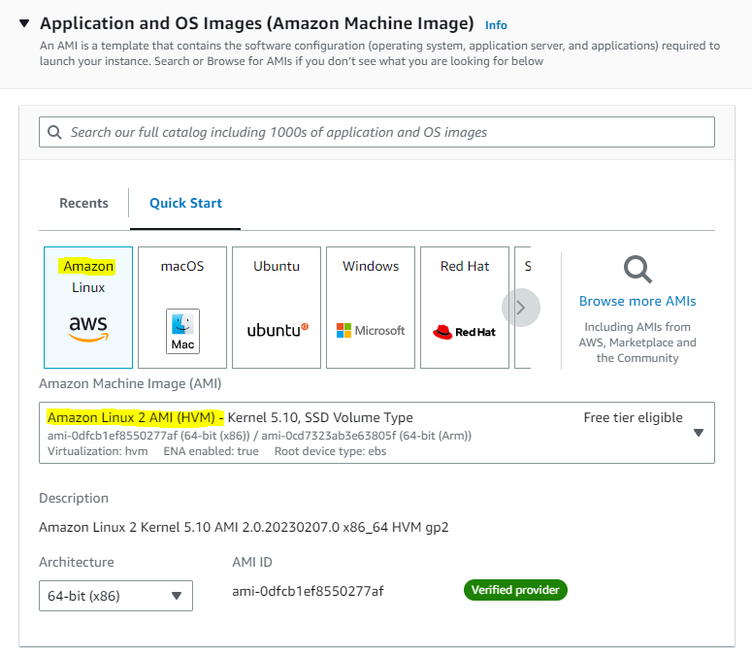

1. Choose the **t2.micro** instance type, which should be default.

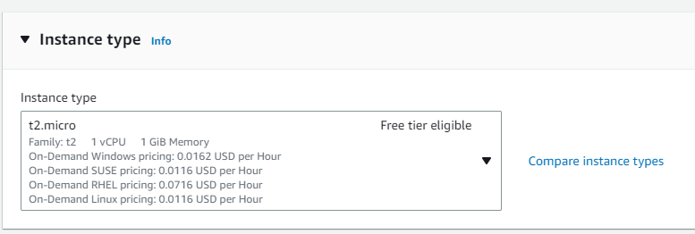

1. For Key pair, use your previous Linux key pair OR click **Create new key pair**. Name the keypair ***yourlastname*-Websvr-key** and select **RSA** and **.ppk** (select **.pem** if you are on a MAC). Click **Create key pair** button and save file.  
   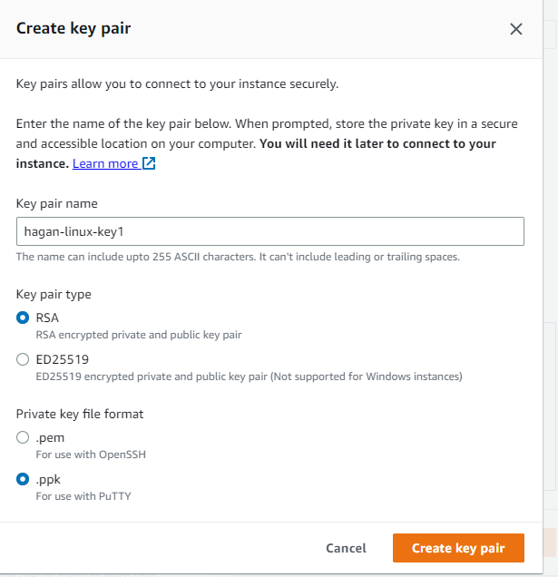
2. On the **Network settings** page, click the **Edit** button, set these values and keep the other values as their defaults:
   * **VPC:** Default.
   * **Subnet:** *No Preference*.
   * **Auto-assign Public IP:** Enable
   * **Select Create security group:** name it ***yourlastname*-WebSvr1-sg**
   * **Inbound security group rules:** Click **Add Security group rule** button and add a rule for SSH and HTTP

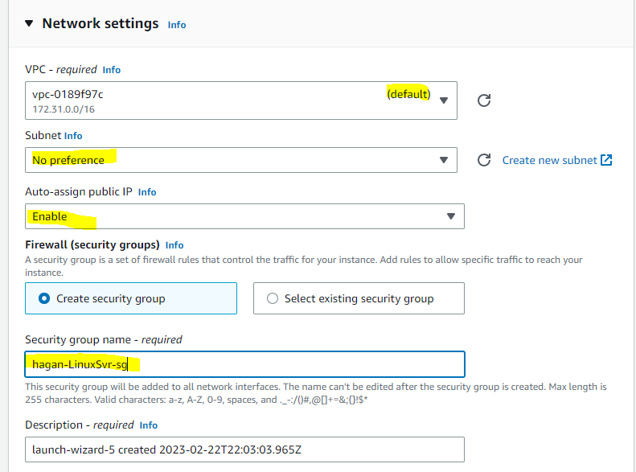

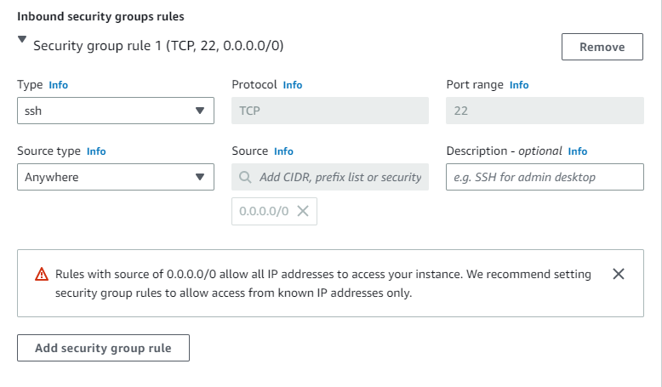

1. For **Configure storage,** leave defaults.
2. For **Advanced details,** leave defaults.
3. Click **Launch Instance**.
4. Click **View Instances** to find your new instance.
5. Wait until **Instance Status** for your instance reads as **Running** and health checks passed before continuing. **Screenshot this and paste to a Word Doc under heading of Screenshot1**.

**Connecting to the Web server Instance**

13) Use Putty (or Terminal on a Mac) to connect to your Web Server Instance as in the previous lab.

14) At the prompt, run the following commands to update the install and download/install the Apache webserver.

sudo yum update -y

sudo yum install -y httpd.x86_64

sudo systemctl start httpd.service

sudo systemctl enable httpd.service

15) Customize the webpage by editing the index.html file. Type **sudo nano /usr/share/httpd/noindex/index.html** to open the file in the Nano editor.

16) Scroll down to the line that says ***<h1>Test Page</h1>*** and change it to ***<h1>yourlastname-WebServer1 Test Page</h1>***

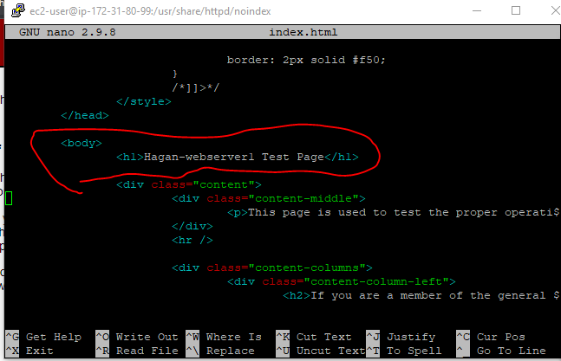

24) Hit **Ctrl-o** to save the changes (you may need to hit **Y** or **Enter** to confirm filename)

25) Hit **Ctrl-x** to exit.

**Testing the WebServer**

1) Go back to the AWS console to your EC2 Webserver instance (check the box) and under the **Detail** tab, click the Copy icon under the ***Public IPV4 DNS***.

2) Open an Incognito (or Private Window in Firefox) in Chrome and Paste/Go the DNS name.

3) You should see your Test Webpage. **Screenshot this and paste to a Word Doc under heading of Screenshot2.**

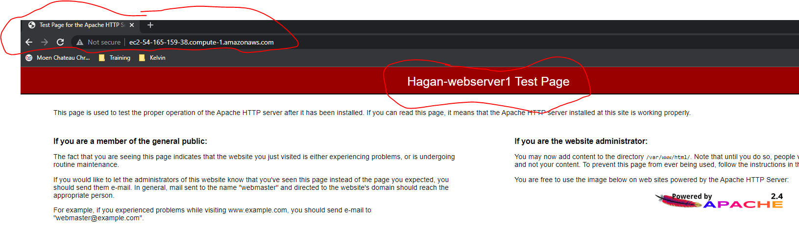

4) To make this page show your actual content, you would create a index.html file and place it in the **/var/www/html/index.html** directory.

**Wrap Up**

1) Stop your EC2 instance by typing **sudo poweroff** in the Putty session. Then go back to the AWS Console and terminate the Instance.

2) Go to the AWS console under EC2 Dashboard and make sure your instances have stopped. You may need to refresh a few times. If it doesn’t stop after some time, check the box next to the instance, go up to the **Instance State** dropdown and select **Stop Instance**.

3) Logout of AWS

4) Upload your Word Doc to Blackboard.